Evolution of the Painted Lady Butterfly

Ishani Mudhdarage
St. Francis College
Evolution
Dr. Tessler
09/15/2021

Evolution of the Painted Lady Butterfly
In biology, evolution is the process by which a species changes its characteristics at different times over the years through natural selection. I visited a small park nearby and observed different species. My focus was on butterflies, particularly the painted lady butterflies. I developed an interest in learning more about the painted lady butterflies and how they evolved over a number of years. I wanted to know why they are the way they are currently in terms of their feeding habits and flight. I found out that painted lady butterflies are found all over the world except in the Antarctica.
Painted lady butterflies are most active during the day. They drink sweet nectar from flowers using their straw-like mouthparts. They use proboscis to feed since some nectar settles deep within a flower. The average lifespan for most butterflies, like the painted lady butterfly, is around two to four weeks. However, in some rare cases, the longest ever lived adult butterfly lives for nine months to one year.
Painted lady butterflies evolved according to the plants they fed on. Flowering plants were their main source of evolution. According to research conducted about painted butterflies, lepidopterans were the oldest ever known ancestors of the painted lady butterflies existed about 300 million years ago (Son & al, 2015). Around 1964, researchers found out that the relationship between flowering plants and painted lady butterflies was directly related to their evolution.
As time went by, flowering plants developed toxins in order to keep off predators such as the painted lady butterflies (Kahawara & al, 2019). As a result, the painted lady butterflies evolved ways of coping up with the toxins in order for them to survive and prevent starvation to death. The earliest butterflies mostly tunneled and fed inside non-vascular plants like bryophytes as larvae. They also had chewing mouthparts as adults. As time went on, they evolved and developed proboscis, which is a coiled straw-like mouthpart that sucks up nectar from flowers, plants sap and other fluids.
Research also shows that painted lady butterflies were a group of moths that evolved and developed hearing organs in nine different stages. The first four stages developed around 91 million years ago, while the remaining five stages evolved in the remaining 209 million years ago. Painted lady butterflies are among the few species of butterflies that have ears on different parts of their body. The ears are as a result of evolution over the years. The development of ears was a defense mechanism against their predators which were mainly the bats. Bats hunted butterflies back then. The butterflies had to develop and evolve in order to battle with the bats. With the evolution of ears, painted lady butterflies slowly developed the capacity to detect pulses and respond with their ability to fly in order to prevent themselves from their prey.
Painted lady butterflies have a slightly large body size which is as a result of evolution from back then where they had a small body size. The large body size helps them to be free and adapt to their surroundings more perfectly. Their large wings also enable them to fly for far distances in search of nectar from flowers. The painted lady butterflies also discovered daylight in their process of evolution. This characteristic developed from a group of moths. As a result of this discovery, the butterflies were able to discover new species of flowering plants (Koltz & al, 2018). In addition, the painted lady butterflies are able to exchange drab, which is useful while they try to signal their mates and pass warnings in case of toxic predators around them.
The current lady butterflies undergo complete metamorphosis. The metamorphosis has four stages which are egg, larvae, pupae and lastly, adult. Their eggs are mint green in color, barrel shaped and are laid singly on the leaves of plants with flowers on which they feed on. The eggs hatch in 3 to 5 days. They hatch into larvae that insulars over 12 to 18 days and change into pupa stage (Talavera & Vila, 2017). The pupa stage lasts about 10 days and finally, they change to butterflies which are the painted lady butterflies that live for about four weeks.
Below is a picture of the butterfly that I observed.

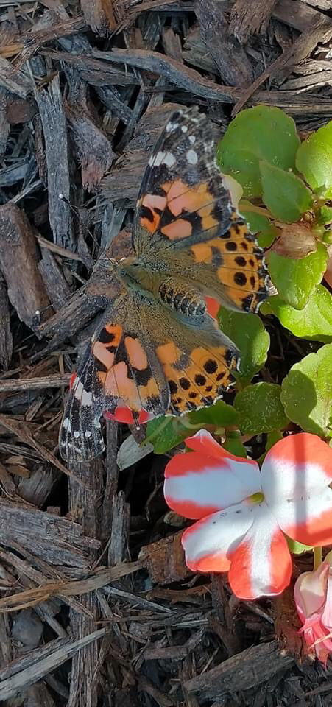
The painted lady butterflies have come a long way over the years. They have evolved with time to become well adapted to their habitats. This has helped to perfect their ways of feeding, protecting themselves from predators and improved their process of movement in search of nectar.

References
Kahawara, A. Y., & al, e. (2019). Phylogenomics reveals the evolutionary timing and pattern of butterflies nad moths . Proceedings of the National Academy of Sciences, 45-46.
Koltz, A. M., & al, e. (2018). Global change and the importance of firefor the ecology and evolution of insects. Current opinion in insect science., 110-116.
Son, J.-C., & al, e. (2015). The fossil record and taphonomy of butterflies and moths (Insecta, Lepidoptera): implications for evolutionary diversity and divergence- time estimates. . BMC Evolutionary Biology, 1-15.
Talavera, G., & Vila, R. (2017). Discovery of mass migrationand breeding of the painted lady butterfly Vanessa cardui in the Sub-Sahara: the Europe-Africa migration revisited. Biological Jourrnal of the Linnean Society, 274-285.

